**🧼 LOCAL, KELLYS HOME & HOUSE CLEANING – SOUTH SARASOTA 🧽 Affordable (Sarasota)**

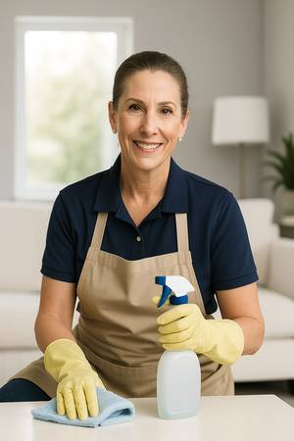



[🧼 LOCAL, KELLYS HOME & HOUSE CLEANING – SOUTH SARASOTA 🧽 Affordable 1 thumbnail](https://images.craigslist.org/00Q0Q_5S728vu9eTm_0gw0oM_600x450.jpg)[🧼 LOCAL, KELLYS HOME & HOUSE CLEANING – SOUTH SARASOTA 🧽 Affordable 2 thumbnail](https://images.craigslist.org/00c0c_3QgDiDaeJwl_0iA0dJ_600x450.jpg)

© craigslist - Map data © [OpenStreetMap](http://www.openstreetmap.org/copyright)

🧼 LOCAL, KELLYS HOME & HOUSE CLEANING – SOUTH SARASOTA 🧽Affordable  
Affordable • Detail-Oriented • Kind-Hearted  
  
Hi, I’m Kelly — born and raised right here in Sarasota, and now offering affordable home cleaning within 7 miles of Bee Ridge. I’m not a cleaning company — just a hardworking local woman rebuilding her life by doing what I do best: making homes clean, calm, and cared for.  
  
💛 Why Choose Me?  
I’ve cleaned professionally for large commercial spaces, so I know how to be thorough, respectful, and dependable.  
  
I’m honest, kind, and committed — I show up, I listen, and I never rush the job.  
  
My rates are lower than most in Sarasota, not because the work is less, but because I’m working independently and building trust one client at a time.  
  
🧽 What I Clean:  
Kitchens, bathrooms, bedrooms, floors, baseboards, fans, blinds, and more  
  
Inside ovens and fridges available  
  
Move-outs / Move-ins / One-time or recurring cleanings  
  
💵 Rates:  
  
2 houra = $50  
3 hours = $75  
4 hours = $100  
  
(Fair, honest pricing — well below local market rates)  
  
📍 I clean in:  
Bee Ridge, Gulf Gate Estates, Southgate, Ridge Wood Heights, Pinecraft, Forest Lakes, and nearby neighborhoods  
📲 Text Kelly at 941-306-9405 – I respond faster to texts  
📅 Available Monday to Saturday – flexible daytime hours  
  
This isn’t just a job to me — it’s a new beginning. If you're looking for someone local who truly cares, I’d love to make your home feel fresh and welcoming.  
  
Thanks for considering me,  
– Kelly